PROJECT REPORT

HOSPITAL MANAGEMENT SYSTEM

INTRODUCTION:

Hospitals are the essential part of our life and providing the best medical facilities to people suffering from various diseases which may due to climatic change conditions etc. It is necessary for the hospitals to keep the trackof its day-to-day activities andrecords of the patient’s personals that keep the hospital running smoothly and successfully.

By keeping the track of all patient records on paper is not possible always and the increase in the population and the number of patients visiting the hospital it is a tough job to keep a record and maintain these details on a paper. Thus, the information of the patients can be kept up to date and their record can be kept for historical purpose.

The main aim of our project is reducing the paper work to hospitals. The system also provides the excellent security of our data at every level user system interaction.

1. What is hospital management system?

Hospital management system is a computer system that helps to manage the information related to health care. In today’sworld, the management of health care starts from the hands of the patients though their mobile phones and facilities needs of the patient.

PROBLEM STATEMENT:

* A system to manage all the activities of the hospital:
* Patients are requests for appointment for any doctor .The details of the existing patients are retrieved by the system .New patients update their details in the system before they request for appointment with the help of receptionist .The receptionist confirms the appointment based on the free slots for the respective doctors and the patients is informed .

HOW PROJECT SOLVES THE PROBLEM:

* The receptionist takes the details of the patient and disease and add the information in the system and confirms that the details are stored or not
* We can search the patients and we can tell them
* We Can edit the patient details if they are written wrong
* We can view how many patients are there and their personal data with suffering disease.

TECHNICAL REQUIREMENTS:

* Windows7/ 8/10
* C compiler(32/64bit)
* By using C-language

ALGORRITHM:

ALGORITHM OF HOSPITAL MANAGEMENT SYSTEM

STEP1: START

STEP2: Enter the username and password

STEP3: Login successful

STEP4: Read the patient name, mobile number, disease, cabin number

STEP5: Enter your choice

STEP6: If you will choose1 you will add patient info

STEP7: How many entries u need

STEP8: If you choose 2 you will view patient info

STEP9: If you choose 3 you will go to search patient info

STEP10: If you choose 4 you will edit patient info

STEP11: STOP .

CONCLUSION:

Hospital management system is essential for maintain the detail about patient records etc. the wok became easy and we save lot of time. It guarantees the accurate maintain of patient record and it easily reduces the book keeping and it reduces the human effect and increases accuracy speed.

FUTURE PROSPECT:

All the work is manually done by receptionist and other staffs and lot of paper is needed to be handled and care of the main activities are performed in a hospital management system and they gave maximum effort to check in the software but in no way alters the ultimate of the project and because its user friendly .most of the analysis are based on interpretations are made for this report.

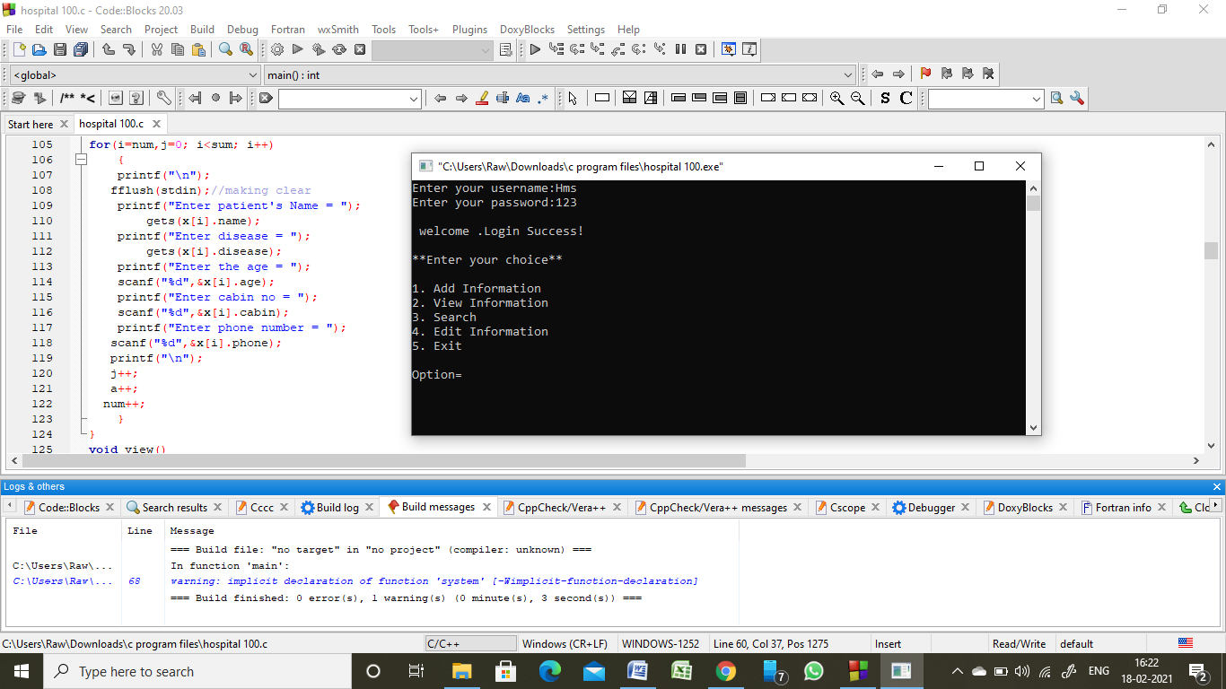

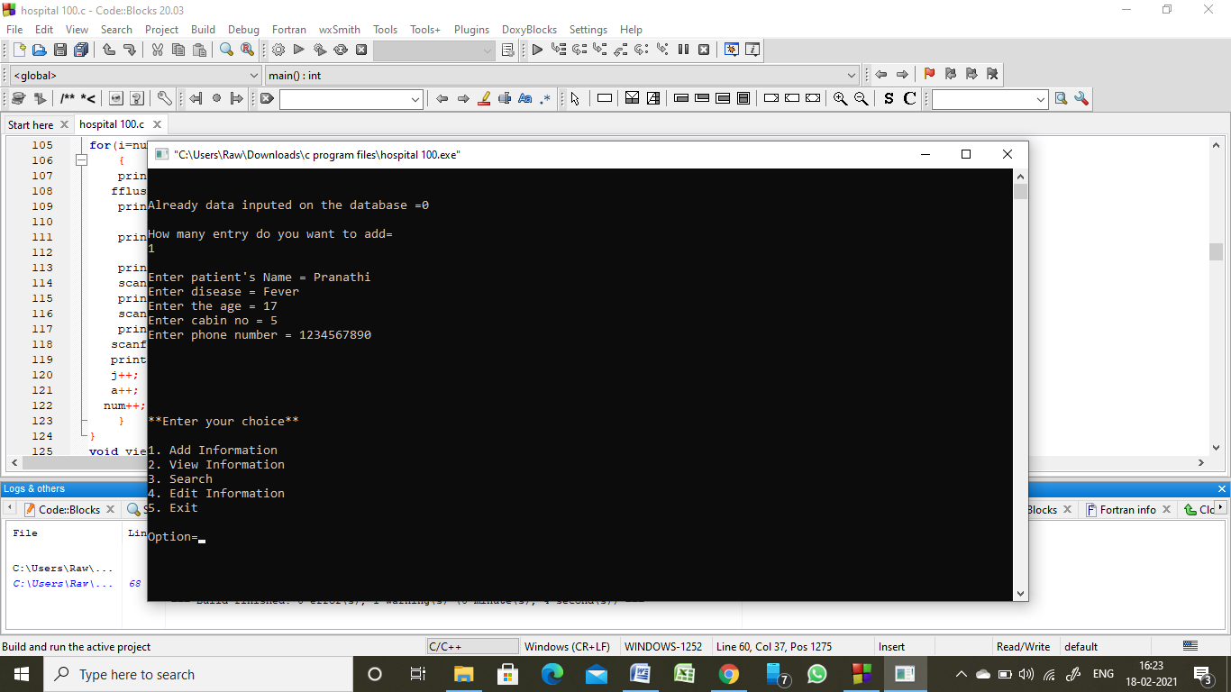

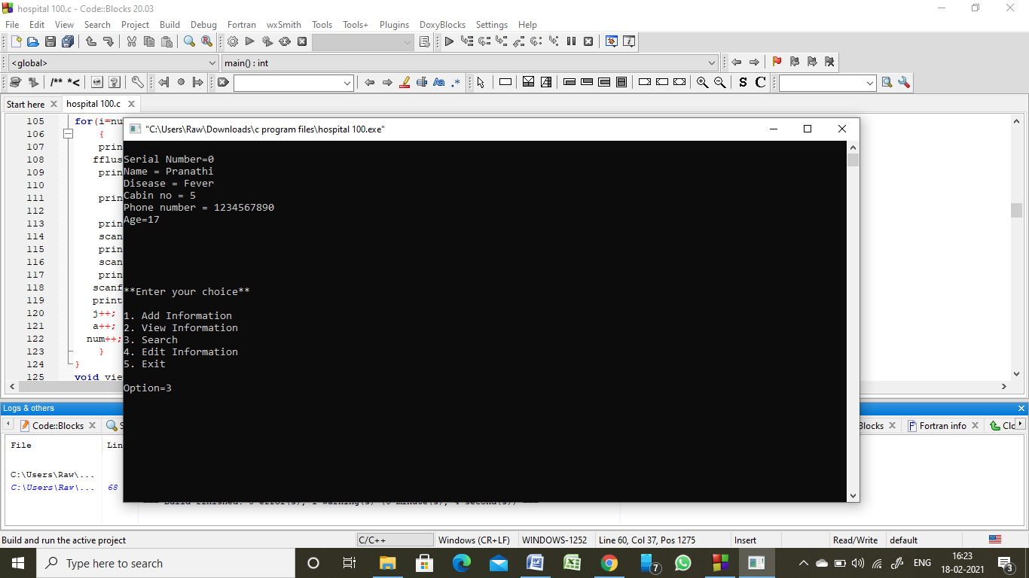

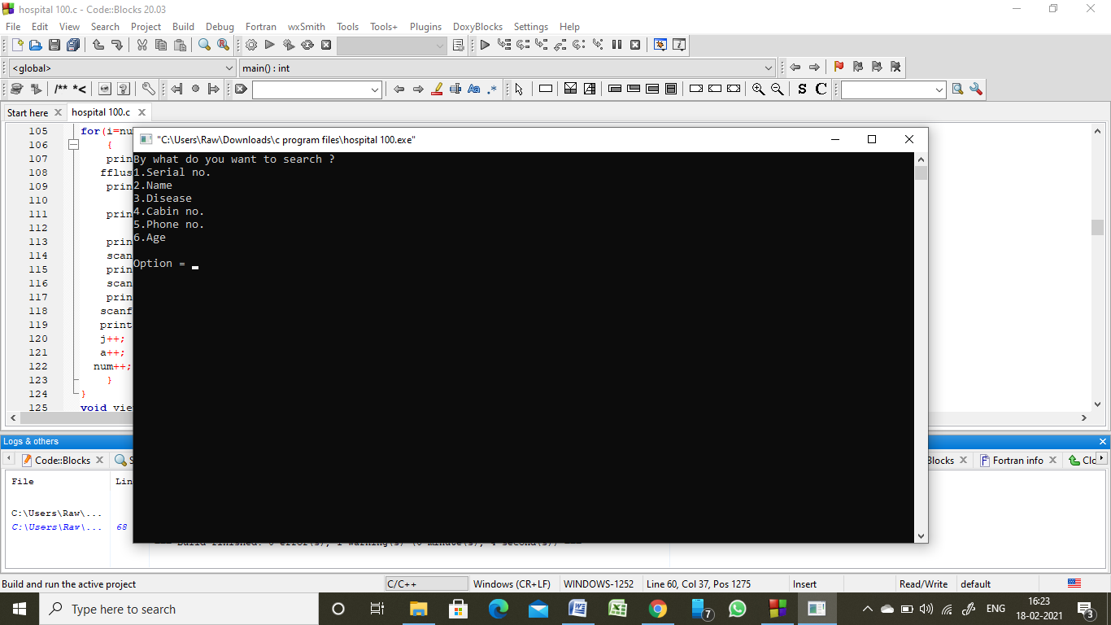

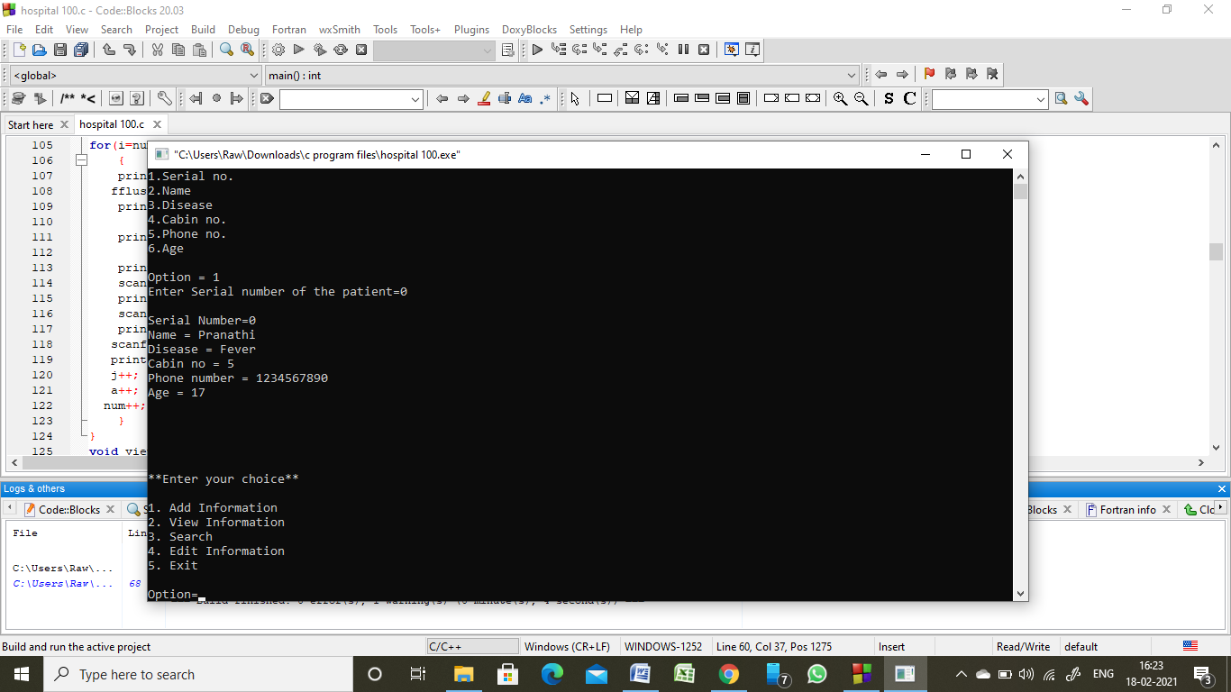

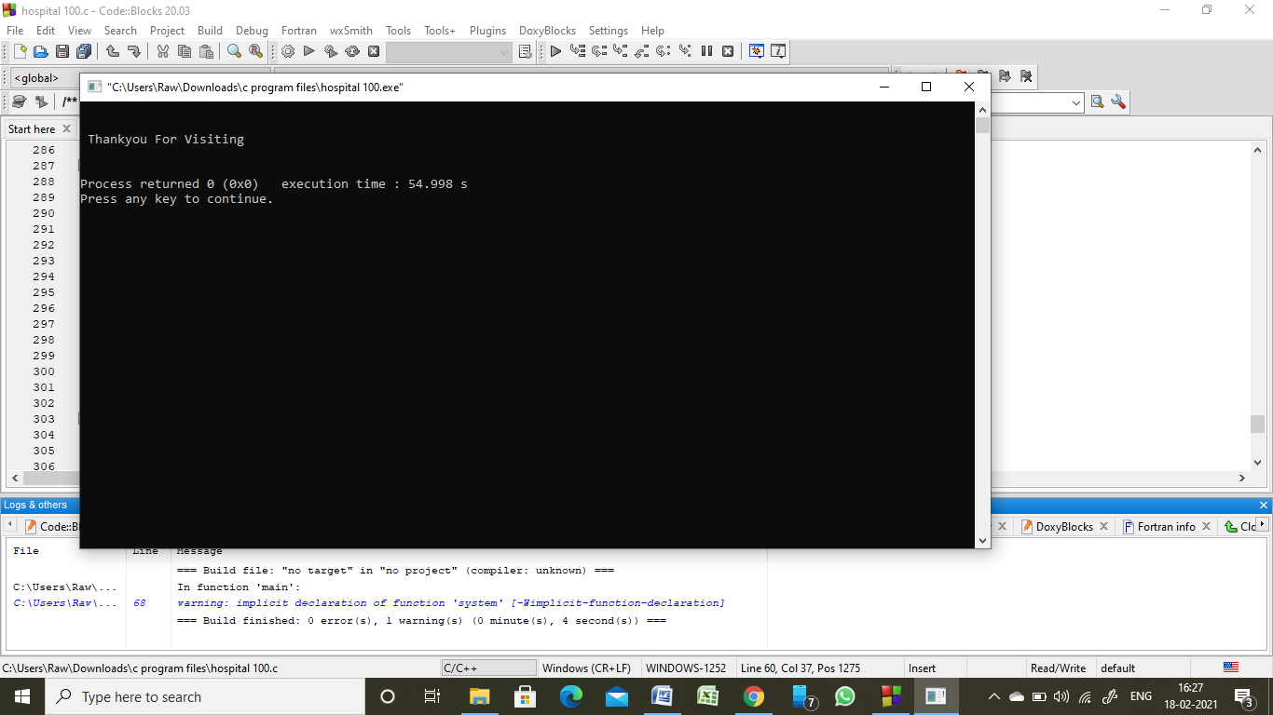

REFERENCES:

* Learnxt(lms)
* Let us C by Yashwant kanetkar(14th edition)